Supplementary Material

SCORE2 risk prediction algorithms:
new models to estimate 10-year risk of cardiovascular disease in Europe

 | Page
Supplementary Methods | 3
Supplementary Table 1: Summary of available data in cohorts used for model derivation | 13
Supplementary Table 2: Summary of available data for derivation of the multiplication factor | 15
Supplementary Table 3: Summary of registry data used to check derived incidence | 16
Supplementary Table 4: Summary of available data in cohorts used for external validation | 17
Supplementary Table 5: Endpoint definitions | 18
Supplementary Table 6: Age- and sex- standardized WHO CVD mortality rates per country | 19
Supplementary Table 7: Summary of subdistribution hazard ratios in the SCORE2 risk models | 20
Supplementary Table 8: Model derivation sensitivity analyses | 21
Supplementary Table 9: Subdistribution hazard ratios in MORGAM/BiomarCaRE consortium | 22
Supplementary Table 10: Multiplication factors by age and sex | 23
Supplementary Table 11: Comparison of the discimination of SCORE and SCORE2 in CPRD | 24
Supplementary Table 12: Discimination of SCORE and SCORE2; sensitivity analysis (AUROC) | 25
Supplementary Figure 1: Data selection for model derivation | 26
Supplementary Figure 2: The relative effect of risk factors at different ages | 27
Supplementary Figure 3: Temporal differences in multiplication factors from CPRD | 28
Supplementary Figure 4: Aggregated and cohort-specific multiplication factors | 29
Supplementary Figure 5: Comparison of SCORE2 multipliers with those from validation cohorts | 30
Supplementary Figure 6: Regional risk factor levels and incidence rates used for recalibration | 31
Supplementary Figure 7: Cardiovascular mortality, derived incidence, and multipliers by risk region | 32
Supplementary Figure 8: Cardiovascular mortality and derived incidence in all risk regions | 33
Supplementary Figure 9: Estimated CVD incidence rates and predicted risks | 34
Supplementary Figure 10: Validation of estimated CVD incidence against independent registry data | 35
Supplementary Figure 11: Predicted 10-year risks for an example individual from each region | 36
Supplementary Figure 12: Distributions of predicted risks for cases and non-cases | 37
Supplementary Figure 13: Comparison of the performance of SCORE and SCORE2 in CPRD | 38
Supplementary Figure 14: Risk stratification with SCORE2 and SCORE and observed lifetime risk | 39
Supplementary Figure 15: SCORE2 risk distributions by age and risk region | 40
List of investigators | 41
Content list

Supplementary Methods
1.1 Model Development
The interlinked stages of model development, including model derivation and recalibration are summarised in Figure 1. An overview of the process is as follows: Fine and Gray models were derived using data from the UK Biobank (UKB) and 43 cohorts included in the Emerging Risk Factor Collaboration (ERFC) (Box 1); Four risk regions in Europe were defined according to the age-standardised country-specific cardiovascular mortality rates. For each region, annual age and sex-specific mortality rates were then translated to 10-year mortality risk estimates, allowing for competing risk of non-CVD death (Box 2); In order to translate 10-year mortality to 10-year risk of fatal and non-fatal CVD, region- age- and sex-specific multiplication factors were estimated using representative registry data and cohorts from each risk region. Multiplication factors were defined as the ratio between the cumulative incidence of fatal and non-fatal CVD events and the cumulative incidence of fatal CVD (Box 3); Multipliers were then used to translate region, sex and age specific 10-year mortality incidence to expected 10-year risk of fatal and non-fatal CVD events (Box 4); Region, sex and age-specific predicted 10-year risks were then estimated using the core, un-calibrated 10-year risk models (derived in Box 1) with region, sex and age-specific risk factors from the Non-Communicable Disease Risk Factor Collaboration (NCD-RisC) (Box 5). The region and sex and age-specific predicted risks (from Box 5) were compared to expected risks (from Box 4) and rescaling factors were estimated to recalibrate the models for each region and sex (Box 6). Finally, the rescaling factors are applied with the original un-calibrated model to give new, recalibrated risk predictions in new individuals (Box 7).

The methods applied in Boxes 1, 2, 3 and 6 warrant further explanation and are detailed as follows:

Box 1: For model derivation, sex-specific coefficients were estimated using Fine and Gray competing risk-adjusted models stratified by cohort. Risk predictors were age, sex, current smoking, history of diabetes mellitus, systolic blood pressure, and total and HDL cholesterol and age-interactions were added for all predictors. Continuous risk predictors were centred before analysis. The SCORE2 risk models are not intended for use in individuals with diabetes since CVD risk among people with diabetes may depend on additional risk factors not considered in SCORE2 (e.g. age of diagnosis, duration, current treatment, and others). However, participants with a history if diabetes were included at the model derivation stage, since they cannot be excluded from population-level mortality statistics and risk factor data used in the re-calibration process. Appropriate adjustment using a dummy-indicator for presence of diabetes mellitus was applied, and this indicator was removed (i.e. set to zero) for individual predictions with the final risk algorithm. There were no or minimal violations of the proportional hazards assumptions as assessed visually based on plotted Schoenfeld residuals. Meta-regression was used to determine temporal or geographical heterogeneity, which was found to be minimal.

Box 2: Estimation of 10-year competing risk adjusted mortality for each risk region
WHO cause-specific mortality rates were supplied by country and coded in ICD-9 or ICD-10. Rates included all mortality which was included in the original SCORE endpoint. Non-CVD mortality was defined as all mortality not included in the SCORE endpoint. Region-level estimates were obtained by taking the age- and sex- specific median of all country-specific estimates of CVD mortality rates from the relevant region.

For every age-group, WHO rates representative of the midpoint of the 10-year interval ahead were used - i.e. for the 40 to 44 year age-group the rates for 45 to 49 years was used. WHO rates of both the fatal cardiovascular outcome and the competing outcome non-CVD mortality were converted to 1–year mortality risks ($r)$ using the following formula:
$$r=1- e^{(-fatal rate)}⁡$$
The 1-year risks of fatal CVD were corrected for the competing risk of non-CVD death and extrapolated to 10-year risks. This was done using life-tables with 1-year intervals, using follow-up time as a timescale. For every interval, CVD-free survival was calculated using the following formula:
$$S_{t+1}= S_{t}×(1-r_{cvd,t}-r_{comp,t}).$$
In which S_{t}=probability of being alive at start of interval t; S_{t+1}=probability of being alive at end of interval t; and $r_{cvd,t}$ and $r_{comp,t }$ are the probabilities of experiencing a fatal CVD event or competing event respectively during interval t, given disease-free survival up to start of interval t; For every 1-year interval of the 10-year time frame of interest, the cause-specific cardiovascular mortality risk was calculated using:
$${CVrisk}_{t}=\frac{r_{cvd,t}}{r_{cvd,t}+r_{comp,t}}* {(S}_{t}-S_{t+1})$$
The fatal 10-year cumulative cause-specific risk was then calculated as the sum of the 1-year cause-specific risks:
$${CVrisk}_{t1-10}= \sum_{1-10}{{CVrisk}_{t}}$$
A worked example of this process is shown in the bottom panel of Table 1, for the 40-45 age group.

Box 3: Estimation of Multipliers to convert mortality to incidence estimates in each risk region
To convert 10-year mortality estimates to incidence estimates, age- and sex-specific multiplication factors were defined as:
$$\frac{{Cumulative 10 year incidence total CV events}_{without prior CVD}}{{Cumulative 10 year incidence fatal CV events}_{entire population}}$$

These allowed the population level mortality statistics, which are calculated among the whole population, regardless of prior disease status, to be converted into first event incidence estimates, representative of the target primary prevention population (those without prior CVD). Multiplication factors were derived in the CPRD cohort, the Swedish Population linked to National Patient Registry and cause of death register, and the Finnish CVD regster data for the low/moderate risk region, the Estonian biobank and the HAPIEE study of Czech Republic for the high and very high risk region. In each cohort and sex, two Fine and Gray models, adjusted for baseline age and age-squared were fit: one modelling 1st CVD event as the outcome and using only individuals without prior CVD, and one with fatal CVD as the outcome and including all participants (regardless of prior disease). In the Finnish register, which provided mortality and incidence rates for three years, 10-year risks were calculated using life-table methods, as described in Box 2 above. The relevant cumulative 10-year incidence was then predicted using each model, for each age group, and age group-specific 10-year CVD event risk was then estimated as follows:

$${CVDrisk}_{total, 10}=\frac{{Cumulative incindence fatal+nonfatal CV events}_{without prior CVD}}{{Cumulative incindence fatal CV events}_{General population}}* {CVrisk}_{t1-10}$$

Multiplication factors were assumed to be stable within each region and over time (supplementary figure 3-5). To aggregate the multipliers from the different cohorts to a single set of multipliers for the low/moderate risk region, the mean was used of the different sets of nationally representative multipliers. For the high/very high risk regions, the mean was calculated of all relevant multipliers, weighted by the size of the multiplier-derivation cohort.

Box 6 Relate expected to predicted risks to calculate rescaling factors for model recalibration
Recalibration of the core SCORE2 models was completed separately for each target region and sex using the previously published general process described in Figure 2. This involved the use of country-sex-specific mean risk factor levels (from NCDRisc) and region-sex-specific estimates of expected cumulative 10-year risk, estimated as described above and in Boxes 2 and 3. We used the core SCORE2 risk models to estimate 10-year predicted risk of each endpoint for each of the age groups (40-80) using the mean risk factor values as described in Box 5. Table 1 shows a worked example for the single age group 40-45, using the model parameters as shown in Table 2. Having completed this process for each age group, as shown in Figure 2 we then regressed transformed expected 10-year risk across age groups on that predicted by the core SCORE2 models to derive recalibration factors (the intercept and slope of the resulting regression line, Table 3). The SCORE2 risk models, rescaled using the recalibration factors were then used to estimate appropriate risks for each potential risk factor combination, for a new individual or for formation of the example risk charts. An example calculation for a new individual is shown in Table 4.

1.2 Missing data
Because complete case analysis may lead to loss of statistical power and possible bias²⁴, values of predictors were imputed by single regression imputation with predictive mean matching for all cohort data.
As the CPRD consists of care-as-usual data, missing data was much more frequent and missingness was more likely to correlate with cardiovascular disease risk. Therefore, multiple imputation was performed for the external validation in CPRD with fully conditional specification using 5 imputed datasets.

1.3 Estimation of nationally representative predicted risk distributions
To compare the proportion of the population at different levels of CVD event risk according to the SCORE2 algorithms, predicted risk distributions were simulated using age- and sex-specific risk factors values means and prevalences from NCD-RisC and correlation structures observed in ERFC cohorts. This involved the following steps for men and women separately:

- Within four subgroups of the population defined according to smoking and diabetes status, and for 5 year age groups (agegrp) between 40 and 70 years a multivariate normal was assumed:

pdf(sbp, tchol, hdl, bmi | agegrp) ~ MVN([mean_sbp, mean_tchol, mean_hdl, mean_bmi], [sd_sbp, sd_tchol, sd_hdl, sd_bmi] & corr_matrix])

where
mean_* = agegrp-specific risk factor means from NCD-RisC
sd_* = global standard deviation calculated using ERFC data
corr_matrix = assumed correlation matrix based on ERFC data

- Under the above assumptions, the probability of belonging to each cell of the risk chart was estimated by integrating the multivariate normal probability density function defined by the parameters and the lower and upper bounds of the risk factor classification.

- The age-specific prevalence of smoking and diabetes from NCD-RisC was used to subdivide the age-specific total population numbers (npop, according to the Global Burden of Disease study 2017) into the four following population subgroups, under the assumption that smoking and diabetes are approximately independent:
a) Non-diabetic, non-smoker = npop*(1 - prev_smoking)*(1 - prev_diabetes)
b) Non-diabetic, smoker = npop*( prev_smoking)*(1 - prev_diabetes)
c) Diabetic, non-smoker = npop*(1 - prev_smoking)*( prev_diabetes)
d) Diabetic, smoker = npop*( prev_smoking)*( prev_diabetes)

- Expected population numbers for each cell of the risk chart were obtained by multiplying the cell probabilities estimated in 2) by the expected population denominators for the 4 population subgroups estimated in 3).

- Estimated expected population numbers from 4) were used as weights when assessing risk distributions based on averaging or classifying the predicted probabilities for each cell of the risk chart (Figure 5 of the main paper and Supplementary Figure 14, which represent those without diabetes only)

Supplementary Methods, Figure 1: SCORE2 Model development process
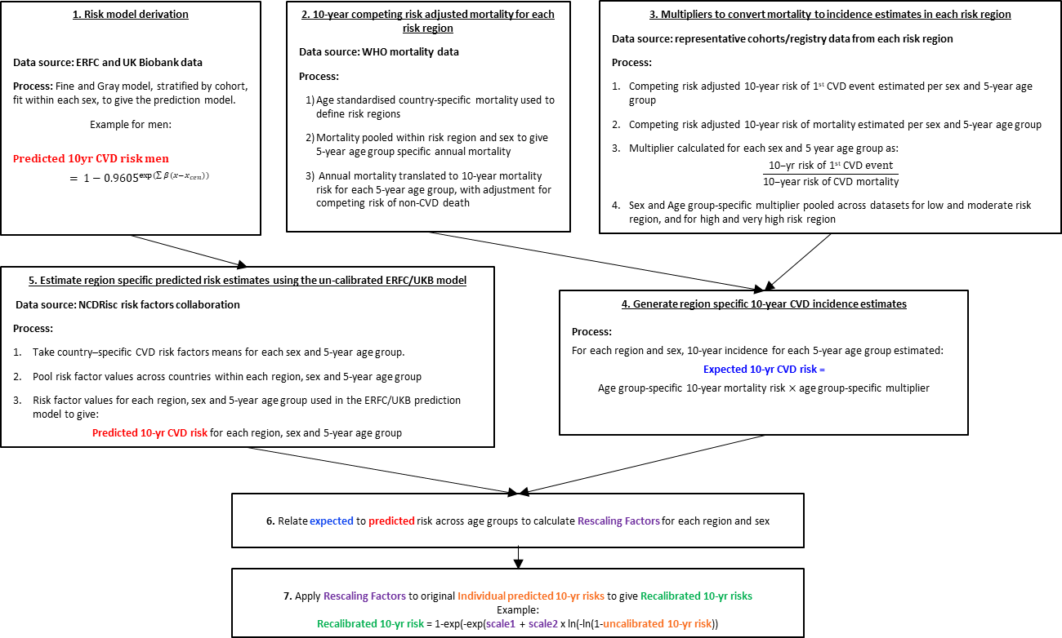

Supplementary Methods, Figure 2: Methods used for recalibration of risk scores
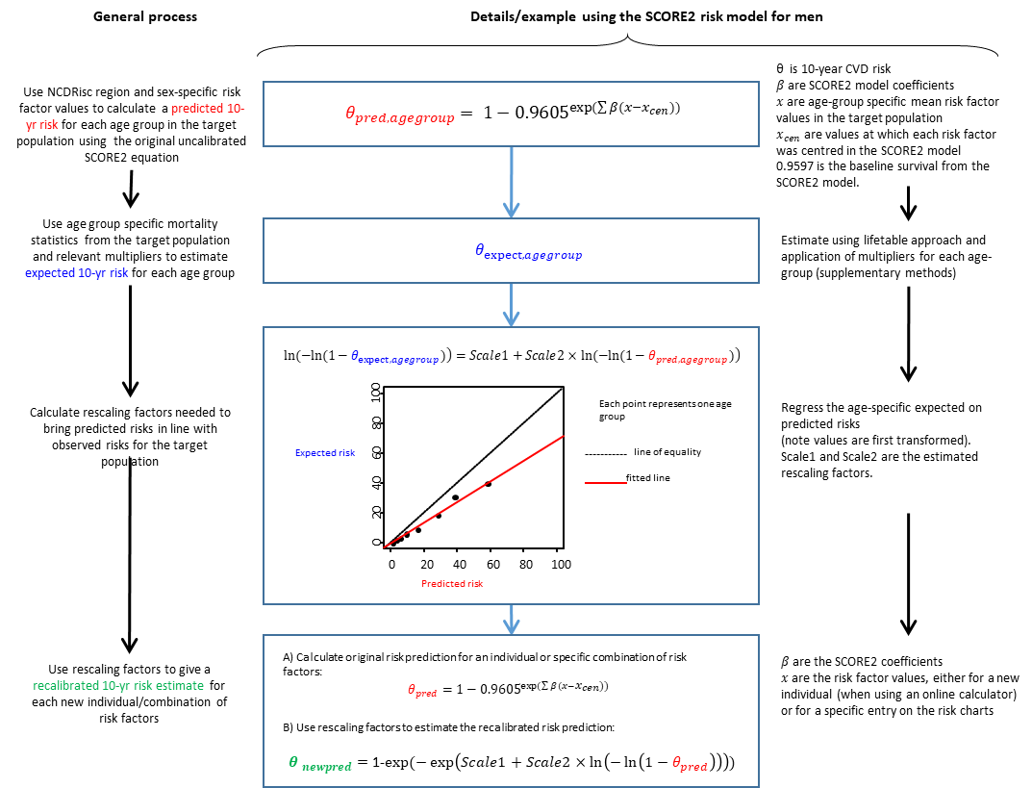

Supplementary Methods, Table 1: Example calculation of predicted and observed 10-year cumulative incidence of CVD for a the male 40-45 year age group based on aggregate level data
Calculation of predicted risk using core ERFC/UKB models – example high risk region men
Mean or prevalence of risk factor values for age group 40-45 |  | Log SHRs from ERFC/UKB fitted model |  |  | Calculation of 10-year cumulative incidence using ERFC/UKB model
Age = 42.5  Total cholesterol = 5.2 mmol/l  HDL cholesterol =1.3  SBP = 132 mmHg  Diabetes=0.07  Smoking=0.45 |  | Age | 0.3742 |  | $\sum{β(x-x_{cen})}$ = 0.3742x (42.5-60)/5  + 0.1458 x (5.2-6)  -0.2698x (1.3-1.3)/0.5  + 0.2777x (132-120)/20  + 0.6457x 0.07  + 0.6012x 0.45  -0.0281x (42.5-60)/5 x (5.2-6)  +0.0426x (42.5-60)/5 x (1.3-1.3)/0.5  -0.0255x (42.5-60)/5 x (132-120)/20  -0.0983x (42.5-60)/5 x 0.07  -0.0755x (42.5-60)/5 x 0.45  = -0.82612  10-yr risk = 1-0.9605^exp($\sum{β}(x-x_{cen}))$  = 1-0.9605^exp(-0.82612)  Predicted risk = 0.01748= 1.7%
 |  | Total cholesterol | 0.1458
 |  | HDL cholesterol | -0.2698
 |  | SBP | 0.2777
 |  | Diabetes | 0.6457
 |  | Smoking | 0.6012
 |  | T. cholesterol interaction with age | -0.0281
 |  | HDL interaction with age | 0.0426
 |  | SBP interaction with age | -0.0255
 |  | Diabetes interaction with age | -0.0983
 |  | Smoking interaction with age | -0.0755
Calculation of observed risk
Annual CVD and non-CVD mortality at the midpoint of the relevant 10-year range (incidence for age group 45-50 used) | Annual cumulative mortality |  |  | Annual cumulative incidence of CVD mortality |  | Expected 10-year cumulative incidence of CVD mortality for the 40-45 year age group | Application of multipliers to give Expected 10-yr cumulative incidence of CVD events
Midpoint of FU range for group with baseline age 40-45 is observed incidence in 45-55 year old  Annual CVD mortality incidence per 100.000 person years=92.7  Incidence per 1 person year: 0.000927  Annual non-CVD mortality incidence per 100000 person years=313  Incidence per 1 person year: 0.0031 | $r_{cvd,t}=1- e^{(-0.000927)}$ = 0.00093  $r_{comp,t}=1- e^{(-0.0031)}$ = 0.0031  Repeat from t=1 to 10:  $$S_{t1}= 1×\left(1-0.00093-0.0031\right)=0.996$$  $$S_{t2}= 0.996×\left(1-0.00093-0.0031\right)$$  $=$0.992  (..)  $$S_{t10}= 0.964×\left(1-0.00093-0.0031\right)$$  = 0.960  $S_{t10}=$ probability of being healthy and alive at the end of $t_{10}$ |  |  | $${CVrisk}_{t}=$$  $\frac{r_{cvd,t}}{r_{cvd,t}+r_{comp,t}}* {(S}_{t}-S_{t+1})$  Repeat from t=1 to 10:  ${CVrisk}_{t1}=$0.$00093$/(0.004) x (1-0.996) = 0.00094  ${CVrisk}_{t2}=$0.$00093$/(0.004) x (0.996-0.992) = 0.00093  (..)  ${CVrisk}_{t10}=$0.00093/(0.004) x (0.964-0.960) = 0.00090 |  | $${CVrisk}_{t1-10}=\sum_{1-10}{{CVrisk}_{t}}$$  = 0.0091  = 0.9% | Region- sex- and age group-specific multiplier = 3.1  10-yr cumulative incidence of CVD events  = 0.0091 x 3.1  = 0.0280  =2.8%

Supplementary methods Table 2: Model coefficients and baseline survival of the SCORE2 algorithm

Risk factor (units) | Transformation | Log SHR |  | SHR
 | equation | Male | Female | Male | Female
Age (yrs) | cage = (age - 60)/5 | 0.3742 | 0.4648 | 1.45 | 1.59
Smoking (current vs. other) | Current = 1, other = 0 | 0.6012 | 0.7744 | 1.82 | 2.17
Systolic blood pressure (SBP, mm Hg) | csbp = (sbp - 120)/20 | 0.2777 | 0.3131 | 1.32 | 1.37
Diabetes* (yes vs. no) | Yes = 1, no = 0 | 0.6457 | 0.8096 | 1.91 | 2.25
Total cholesterol (mmol/L) | ctchol = (tchol - 6)/1 | 0.1458 | 0.1002 | 1.16 | 1.11
HDL cholesterol (mmol/L) | chdl = (hdl - 1.3)/0.5 | -0.2698 | -0.2606 | 0.76 | 0.77
Smoking x age interaction | cage x smoking | -0.0755 | -0.1088 | 0.93 | 0.90
SBP x age interaction | cage x csbp | -0.0255 | -0.0277 | 0.98 | 0.97
Total cholesterol x age interaction | cage x ctchol | -0.0281 | -0.0226 | 0.97 | 0.98
HDL cholesterol x age interaction | cage x chdl | 0.0426 | 0.0613 | 1.04 | 1.06
Diabetes* x age interaction | cage x diabetes | -0.0983 | -0.1272 | 0.91 | 0.88
Baseline survival |  | 0.9605 | 0.9776

*Diabetes mellitus was included in the modelling since this was necessary for the recalibration approach, which relies data from the whole population, including those with diabetes. However, SCORE2 is not intended for use in individuals with diabetes and has not been validated in this population. For risk prediction in the target population of individuals without diabetes this risk factor will always be 0, meaning the coefficient can effectively be ignored.

Supplementary methods Table 3: Region and sex-specific recalibration scales of the SCORE2 algorithm

 | Male |  | Female
Risk region | Scale1 | Scale2 | Scale1 | Scale2
Low risk region | -0.5699 | 0.7476 | -0.7380 | 0.7019
Moderate risk region | -0.1565 | 0.8009 | -0.3143 | 0.7701
High risk region | 0.3207 | 0.9360 | 0.5710 | 0.9369
Very high risk region | 0.5836 | 0.8294 | 0.9412 | 0.8329

Rescaling factors for the SCORE2 model to scale individual predicted risks to the target population, based recent nationally representative estimates of incident cardiovascular disease and risk factor levels.

Supplementary methods Table 4: Illustration of risk estimation for a non-diabetic man or woman with given risk factor values

1) Calculation of Linear Predictor
Risk factor (units) |  | Risk FactorValue | Transformed  value |  | Log HRx transformed value
 |  |  |  |  | Male |  |  |  |  | Female
Age (yrs) |  | 50 | (50-60)/5 = -2 |  | 0.3742 x -2 |  | = -0.7484 |  |  | 0.4648 x -2 | = -0.9296
Smoking (current vs. other) |  | yes | 1 |  | 0.6012 x 1 |  | = 0.6012 |  |  | 0.7744 x 1 | = 0.7744
Systolic blood pressure (SBP, mm Hg) |  | 140 | (140 - 120)/20 = 1 |  | 0.2777 x 1 |  | = 0.2777 |  |  | 0.3131 x 1 | = 0.3131
Total cholesterol (mmol/L) |  | 6.3 | (6.3 - 6)/1 = 0.3 |  | 0.1458 x 0.3 |  | = 0.04374 |  |  | 0.1002 x 0.3 | = 0.03006
HDL cholesterol (mmol/L) |  | 1.4 | (1.4- 1.3)/0.5 = 0.2 |  | -0.2698 x 0.2 |  | = -0.05396 |  |  | -0.2606 x 0.2 | = -0.05212
Smoking x age interaction |  |  | -2 x 1 = -2 |  | -0.0755 x -2 |  | = 0.151 |  |  | -0.1088 x -2 | = 0.2176
SBP x age interaction |  |  | -2 x 1 = -2 |  | -0.0255 x -2 |  | = 0.051 |  |  | -0.0277 x -2 | = 0.0554
Total cholesterol x age interaction |  |  | -2 x 0.3 = -0.6 |  | -0.0281 x -0.6 |  | = 0.01686 |  |  | -0.0226 x -0.6 | = 0.01356
HDL cholesterol x age interaction |  |  | -2 x 0.2 = -0.4 |  | 0.0426 x -0.4 |  | = -0.01704 |  |  | 0.0613 x -0.4 | = -0.02452
 |  |  |  | Linear predictor: | ∑ = 0.3221 |  |  |  |  | ∑ = 0.39788
2) 10-year risk estimation (un-calibrated) = 1-basesurv ^{exp(linear predictor)}
 |  |  | Male  1-0.9605 ^{exp(0.3221)}=0.0541 |  |  |  |  | Female  1-0.9776 ^{exp(0.39788)}=0.0332
3) Calibration of risk estimate according to region specific scaling factors
Calibrated 10-year risk = 1-exp(-exp(scale1 + scale2 x ln(-ln(1-un-calibrated 10-yr risk))
Risk region | Male |  |  |  |  | Female
Low | 1-exp(-exp(-0.5699+0.7476 x ln(-ln(1-0.0541))))  = 0.0631 |  |  |  |  | 1-exp(-exp(-0.7380+0.7019 x ln(-ln(1-0.0332))))  = 0.0434
Moderate | 1-exp(-exp(-0.1565+0.8009 x ln(-ln(1-0.0541))))  = 0.0811 |  |  |  |  | 1-exp(-exp(-0.3143+0.7701 x ln(-ln(1-0.0332))))  = 0.0523
High | 1-exp(-exp(0.3207+0.9360 x ln(-ln(1-0.0541))))  = 0.0881 |  |  |  |  | 1-exp(-exp(0.5710+0.9369 x ln(-ln(1-0.0332))))  = 0.0713
Very high | 1-exp(-exp(0.5836+0.8294 x ln(-ln(1-0.0541))))  = 0.1506 |  |  |  |  | 1-exp(-exp(0.9412+0.8329 x ln(-ln(1-0.0332))))  = 0.1414
Note: final estimate should be multiplied by 100 in order to express as a percentage rather than a probability

Supplementary Table 1: Summary of available data in cohorts used for model derivation
Country | Cohort | No of  partici-  pants | Ages  Mean (SD) | Men  n (%) | Current  smoker  n (%) | Systolic BP  (mmhg)  Mean(SD) | Total cholesterol  (mmol/L)  Mean (SD) | HDL cholesterol  (mmol/L)  Mean (SD) | Diabetes  n (%) | Median  follow up  (5th and 95th percentile) | CVD | CVD before 10-years | 0ther death | Other death before 10 years | Median year  of study  recruitment
Europe
Denmark | COPEN | 6780 | 61 (10) | 2854 (42) | 3426 (51) | 141 (22) | 6.3 (1.2) | 1.60 (0.51) | 224 (3.3) | 16.4 (2.3 to 18.4) | 1554 | 941 | 1684 | 860 | 1993
France | DESIR | 3328 | 52 (7) | 1636 (49) | 543 (16) | 133 (16) | 5.9 (1.0) | 1.65 (0.44) | 225 (6.8) | 9.0 (3.0 to 9.3) | 50 | 50 | 1 | 1 | 1995
France / NI | PRIME | 9583 | 55 (3) | 9583 (100) | 2544 (27) | 134 (19) | 5.7 (1.0) | 1.26 (0.33) | 312 (3.3) | 5.2 (5.0 to 26.0) | 580 | 298 | 710 | 236 | 1992
Germany | ESTHER | 7823 | 61 (7) | 3316 (42) | 1341 (17) | 139 (20) | 5.7 (1.3) | 1.40 (0.40) | 928 (11.9) | 5.0 (2.0 to 5.9) | 223 | 223 | 74 | 74 | 2001
Germany | SHIP | 2575 | 58 (11) | 1255 (49) | 651 (25) | 141 (21) | 6.1 (1.2) | 1.45 (0.45) | 360 (14.0) | 10.3 (0.0 to 11.9) | 54 | 46 | 0 | 0 | 1999
Greek | ATTICA | 1960 | 53 (10) | 993 (51) | 808 (41) | 128 (19) | 5.3 (1.0) | 1.25 (0.39) | 192 (9.8) | 5.0 (5.0 to 10.0) | 25* | 25* | 15 | 15 | 2001
Italy | ATENA | 4408 | 51 (7) | 0 (0) | 1738 (39) | 135 (21) | 6.2 (1.2) | 1.62 (0.42) | 115 (2.6) | 6.8 (5.2 to 8.1) | 30 | 30 | 29 | 29 | 1995
Italy | BRUN | 800 | 57 (11) | 391 (49) | 195 (24) | 145 (22) | 5.7 (1.0) | 1.47 (0.37) | 29 (3.6) | 20.2 (4.5 to 20.5) | 143 | 52 | 150 | 70 | 1990
Italy | EMOFRI | 360 | 55 (6) | 176 (49) | 92 (26) | 146 (18) | 5.9 (1.1) | 1.54 (0.42) | 17 (4.7) | 6.8 (6.5 to 7.2) | 8 | 8 | 5 | 5 | 1996
Italy | MATISS93 | 989 | 52 (8) | 492 (50) | 248 (25) | 142 (23) | 5.7 (1.1) | 1.30 (0.36) | 55 (5.6) | 8.3 (7.0 to 9.3) | 28 | 28 | 16 | 16 | 1994
Italy | MONFRI94 | 1091 | 51 (7) | 522 (48) | 275 (25) | 140 (20) | 5.9 (1.1) | 1.50 (0.39) | 55 (5.0) | 8.5 (6.9 to 8.8) | 39 | 39 | 26 | 26 | 1994
Netherlands | HOORN | 2285 | 61 (7) | 1009 (44) | 725 (32) | 135 (20) | 6.7 (1.2) | 1.34 (0.37) | 219 (9.6) | 8.8 (3.5 to 9.9) | 177 | 177 | 149 | 149 | 1991
Netherlands | MORGEN | 13214 | 50 (6) | 6064 (46) | 4779 (36) | 125 (17) | 5.6 (1.0) | 1.37 (0.39) | 220 (1.7) | 10.7 (4.3 to 13.0) | 139* | 104* | 418 | 317 | 1995
Netherlands | PREVEND | 4934 | 54 (10) | 2380 (48) | 1619 (33) | 132 (21) | 5.9 (1.1) | 1.33 (0.40) | 223 (4.5) | 10.6 (3.6 to 11.2) | 253 | 233 | 290 | 258 | 1998
Netherlands | ProspectEPIC | 15819 | 57 (6) | 0 (0) | 3589 (23) | 133 (20) | 6.1 (1.1) | 1.49 (0.41) | 321 (2.0) | 14.3 (7.6 to 17.2) | 740 | 516 | 935 | 571 | 1995
Netherlands | RS_I | 4448 | 66 (7) | 1745 (39) | 1086 (24) | 138 (22) | 6.7 (1.2) | 1.38 (0.38) | 281 (6.3) | 12.0 (3.5 to 14.2) | 611 | 431 | 752 | 521 | 1992
Netherlands | RS_II | 2104 | 63 (6) | 930 (44) | 519 (25) | 142 (21) | 5.9 (0.9) | 1.39 (0.37) | 212 (10.1) | 10.1 (4.2 to 10.9) | 141 | 134 | 167 | 164 | 2000
Norway | FINNMARK | 5266 | 59 (9) | 2352 (45) | 1933 (37) | 140 (23) | 6.1 (1.1) | 1.50 (0.42) | 213 (4.0) | 7.5 (5.0 to 7.5) | 116* | 116* | 267 | 267 | 2002
Norway | HUBRO | 14141 | 54 (13) | 6132 (43) | 4037 (29) | 135 (19) | 5.8 (1.1) | 1.52 (0.43) | 411 (2.9) | 8.5 (6.0 to 9.5) | 240* | 238* | 748 | 744 | 2001
Norway | OPPHED | 9484 | 52 (12) | 4282 (45) | 2969 (31) | 135 (22) | 5.8 (1.1) | 1.38 (0.37) | 233 (2.5) | 8.5 (7.0 to 9.5) | 162* | 162* | 424 | 424 | 2001
Norway | OSLO2 | 5108 | 69 (7) | 5108 (100) | 1116 (22) | 147 (21) | 6.1 (1.0) | 1.44 (0.40) | 267 (5.2) | 9.5 (3.0 to 9.5) | 270* | 270* | 828 | 828 | 2000
Norway | TROMS | 1977 | 51 (12) | 853 (43) | 679 (34) | 135 (21) | 5.8 (1.1) | 1.41 (0.37) | 57 (2.9) | 7.5 (7.5 to 7.5) | 26* | 26* | 52 | 52 | 2002
Scotland/Ireland/Netherlands | PROSPER | 1511 | 74 (3) | 647 (43) | 542 (36) | 156 (21) | 5.7 (0.9) | 1.31 (0.35) | 181 (12.0) | 3.2 (1.1 to 3.9) | 184 | 184 | 66 | 66 | 1998
Spain | DRECE | 1477 | 50 (6) | 699 (47) | 390 (26) | 127 (19) | 5.6 (1.1) | 1.42 (0.38) | 153 (10.4) | 19.3 (11.9 to 19.6) | 38* | 15* | 130 | 43 | 1991
Spain | ZARAGOZA | 4176 | 58 (11) | 1849 (44) | 801 (19) | 133 (16) | 5.9 (1.0) | 1.42 (0.36) | 532 (12.7) | 5.1 (4.7 to 5.1) | 114 | 114 | 2 | 2 | 1994
Sweden | GOTO43 | 775 | 50 (0) | 775 (100) | 239 (31) | 130 (16) | 5.9 (1.0) | 1.31 (0.34) | 16 (2.1) | 11.0 (7.9 to 11.7) | 47 | 41 | 21 | 20 | 1993
Sweden | MOSWEGOT | 2915 | 52 (7) | 1358 (47) | 837 (29) | 132 (19) | 6.1 (1.2) | 1.45 (0.42) | 85 (2.9) | 13.8 (6.0 to 19.6) | 284 | 170 | 158 | 104 | 1990
UK | BWHHS | 3263 | 68 (5) | 0 (0) | 391 (12) | 148 (25) | 6.7 (1.2) | 1.67 (0.45) | 141 (4.3) | 12.2 (3.3 to 13.3) | 347 | 264 | 494 | 372 | 2000
UK | EPICNOR1 | 20833 | 59 (9) | 9236 (44) | 2415 (12) | 135 (18) | 6.2 (1.2) | 1.43 (0.43) | 597 (2.9) | 9.7 (5.9 to 12.0) | 960 | 872 | 0 | 0 | 1996
UK | HCS | 2707 | 66 (3) | 1356 (50) | 369 (14) | 133 (19) | 6.3 (1.1) | 1.54 (0.42) | 350 (12.9) | 8.9 (5.6 to 11.6) | 62* | 57* | 205 | 198 | 2001
UK | LEADER | 427 | 67 (8) | 427 (100) | 168 (39) | 149 (22) | 5.7 (0.9) | 1.22 (0.39) | 64 (15.0) | 4.3 (1.0 to 6.8) | 76 | 76 | 36 | 36 | 1997
UK | MIDFAM | 1826 | 47 (5) | 801 (44) | 453 (25) | 128 (16) | 5.4 (1.0) | 1.42 (0.37) | 25 (1.4) | 17.4 (9.6 to 17.8) | 97 | 46 | 98 | 46 | 1996
UK | UKB | 431965 | 56 (8) | 192334 (45) | 45305 (10) | 138 (19) | 5.8 (1.1) | 1.46 (0.38) | 18452 (4.3) | 10.8 (7.8 to 12.4) | 13778 | 11939 | 15947 | 13637 | 2009
UK | WHITEI | 3137 | 75 (3) | 3137 (100) | 427 (14) | 145 (20) | 5.6 (1.0) | 1.11 (0.38) | 142 (4.5) | 12.9 (2.5 to 13.3) | 529* | 368* | 930 | 660 | 1997
UK | WHITEII | 8621 | 50 (6) | 5907 (69) | 1636 (19) | 121 (14) | 6.5 (1.2) | 1.44 (0.41) | 148 (1.7) | 12.2 (3.9 to 13.0) | 323 | 323 | 280 | 280 | 1992
UK | WOSCOPS | 3293 | 55 (6) | 3293 (100) | 1460 (44) | 136 (17) | 7.0 (0.6) | 1.14 (0.25) | 35 (1.1) | 4.8 (2.5 to 6.0) | 300 | 300 | 59 | 59 | 1990
Subtotal (Europe) |  | 605403 | 57 (9) | 273892 (45) | 90345 (15) | 137 (19) | 5.8 (1.1) | 1.45 (0.39) | 26090 (4.3) | 10.6 (5.0 to 13.0) | 22748 | 18916 | 26166 | 21150
Country | Cohort | No of  partici-  pants | Ages  Mean (SD) | Men  n (%) | Current  smoker  n (%) | Systolic BP  (mmhg)  Mean(SD) | Total cholesterol  (mmol/L)  Mean (SD) | HDL cholesterol  (mmol/L)  Mean (SD) | Diabetes  n (%) | Median  follow up  (5th and 95th percentile) | CVD | CVD before 10-years | 0ther death | Other death before 10 years | Median year  of study  recruitment
Americas
Canada | NSHS | 1146 | 57 (11) | 552 (48) | 295 (26) | 129 (17) | 5.6 (1.0) | 1.29 (0.37) | 70 (6.1) | 9.7 (4.3 to 10.0) | 51 | 51 | 96 | 96 | 1995
USA | ARIC | 12006 | 57 (6) | 5365 (45) | 2927 (24) | 121 (19) | 5.4 (1.0) | 1.29 (0.43) | 1771 (14.8) | 25.3 (4.3 to 27.6) | 2798 | 2798 | 3126 | 3126 | 1991
USA | CHS1 | 3380 | 71 (4) | 1250 (37) | 433 (13) | 135 (21) | 5.5 (1.0) | 1.44 (0.41) | 434 (12.8) | 12.2 (2.4 to 12.9) | 893 | 674 | 619 | 449 | 1989
USA | CHS2 | 414 | 71 (4) | 155 (37) | 70 (17) | 142 (24) | 5.4 (1.0) | 1.49 (0.40) | 96 (23.2) | 9.1 (1.9 to 9.5) | 83 | 83 | 49 | 49 | 1993
USA | HONOL | 1877 | 76 (2) | 1877 (100) | 152 (8) | 148 (22) | 5.0 (0.8) | 1.33 (0.34) | 485 (25.8) | 6.3 (1.5 to 7.6) | 204 | 204 | 255 | 255 | 1992
USA | MESA | 6515 | 61 (10) | 3082 (47) | 1008 (15) | 126 (21) | 5.0 (0.9) | 1.32 (0.38) | 814 (12.5) | 15.7 (2.8 to 17.1) | 504 | 310 | 467 | 251 | 2001
USA | NHANESIII | 8242 | 58 (12) | 3838 (47) | 2208 (27) | 132 (20) | 5.6 (1.1) | 1.33 (0.41) | 860 (10.4) | 18.4 (3.8 to 22.4) | 1143* | 519* | 2248 | 843 | 1990
USA | USPHS2 | 10724 | 64 (8) | 10724 (100) | 507 (5) | 128 (12) | 5.3 (0.9) | 1.15 (0.38) | 25 (0.2) | 10.9 (4.9 to 11.5) | 645 | 634 | 690 | 626 | 1997
USA | WHS | 27977 | 55 (7) | 0 (0) | 3266 (12) | 127 (12) | 5.5 (1.1) | 1.39 (0.39) | 768 (2.7) | 19.1 (8.9 to 20.0) | 1052 | 560 | 93 | 36 | 1994
Subtotal (Americas) |  | 72281 | 59 (9) | 26843 (37) | 10866 (15) | 128 (17) | 5.4 (1.0) | 1.32 (0.41) | 5323 (7.4) | 17.1 (4.6 to 26.2) | 7373 | 5833 | 7643 | 5731
TOTAL |  | 677684 | 57 (9) | 300735 (44) | 101211 (15) | 136 (19) | 5.8 (1.1) | 1.44 (0.40) | 31413 (4.6) | 10.7 (5.0 to 18.6) | 30121 | 24749 | 33809 | 26881
*CVD events include only fatal events

Supplementary Table 2: Summary of data sources for derivation of the multiplication factors
Risk region | Country | Data source | Number of participants | Ages  Mean (SD) | Men  n (%) | Median follow-up years (IQR) | CV events | Median year  of study  recruitment
Low | United Kingdom | CPRD | 2,589,074 | 53.2 (13.8) | 1,293,091 (49%) | 7.5 (3.4-11.0) | 119,656 | 2004
Moderate | Sweden | Swedish Population data* | 5,344,076 | 57.9 (14.7) | 2,598,559 (48%) | 10.0 (10.0-10.0) | 588,148 | 2009
Moderate | Finland | Finnish CVD Register | 2,766,988 | 59.5 (11.7) | 1,338,807 (48%) | N/A** | 16,511 | 2015**
High | Estonia | Estonian Biobank | 67,471 | 55.16 (10.8) | 21433 (31.8%) | 0.76 (0.21-8.87) | 5780 | 2018
High | Czech Republic | HAPIEE | 8,857 | 57.7 (8.9) | 4123 (47%) | 15.1 (14.2-15.8) | 1170 | 2003
*endpoints were obtained through linkage to the Swedish National Inpatient Register and Swedish cause of death registry
**Annual rates were averaged over a three year period (2014-2016) and extrapolated to estimates 10-year risks (see Supplementary methods)

Supplementary Table 3: Summary of registry data used to check derived incidence
Registry data sources (all from year 2018):
 | Country | Source | Reference | ICD codes included in endpoint
Mortality data | The Netherlands | CBS statistics Netherlands | https://www.volksgezondheidenzorg.info/ | I0-99
 | Denmark | Hjerteforeningen | https://hjerteforeningen.dk/ | I0-99
 | United Kingdom | Office of National Statistics | https://www.nomisweb.co.uk/ | I0-99
 | Germany | Destatis | https://www-genesis.destatis.de/ | I0-99
 | Spain | National Institute of Statistics | https://www.ine.es | I10:16, 20:25 46:52, 60:69; 70:73; R96
Incidence data | The Netherlands | Dutch Hospital Data | https://www.dhd.nl/ | I21; I60-69
 | Denmark | Hjerteforeningen | https://hjerteforeningen.dk/ | I21-22; I60-69
 | United Kingdom | British Heart Foundation | https://www.bhf.org.uk/ | I21; I60-69
 | Germany | Destatis | https://www-genesis.destatis.de/ | I21-23; I60-69
 | Spain | National Institute of Statistics | https://www.ine.es | I21-23; I6-69

Supplementary Table 4: Summary of available data in cohorts used for external validation
Data sources | Country | Cohort | Risk region | No of  participants | Ages  Mean (SD) | Men  n (%) | Current  smoker  n (%) | Systolic BP  (mmhg)  Mean (SD) | Total cholesterol  (mmol/L)  Mean (SD) | HDL cholesterol  (mmol/L)  Mean (SD) | Median follow-up years (IQR) | CVD events* | Median year  of study  recruitment
MORGAM/BIOMARCARE | Denmark | DanMONICA I | Low | 1970 | 51.1 (8.1) | 959 (49) | 1027 (52) | 126 (18) | 6.1 (1.1) | 1.4 (0.4) | 16.6 (16.1-17.1) | 205 | 1994
MORGAM/BIOMARCARE | Denmark | DanMONICA III | Low | 979 | 53.4 (8.5) | 484 (49) | 496 (51) | 127 (18) | 6.1 (1.1) | 1.5 (0.4) | 19.3 (16.1-19.6) | 159 | 1991
EPIC-CVD | Denmark | EPIC-CVD | Low | 5436 | 58 (4) | 3287 (60) | 2415 (44) | 145 (22) | 6.2 (1.2) | 1.36 (0.45) | 10.4 (5.9 to 13) | 3545 | 1996
EPIC-CVD | France | EPIC-CVD | Low | 599 | 56 (6) | 0 (0) | 56 (9) | 125 (18) | 6.0 (1.0) | 1.84 (0.41) | 10.5 (9.7 to 11) | 36 | 1997
HUNT | Norway | HUNT | Low | 31473 | 53.1 (8.5) | 14793 (47) | 10270 (33) | 138 (20) | 6.2 (1.2) | 1.4 (0.4) | 22.1 (19.1-22.8) | 5630 | 1996
MORGAM/BIOMARCARE | Norway | Tromso 1994-1995 | Low | 12919 | 51.6 (8.1) | 6162 (48) | 4985 (39) | 138 (19) | 6.3 (1.2) | 1.5 (0.4) | 15.8 (14.2-16.1) | 1352 | 1995
MORGAM/BIOMARCARE | Spain | MONICA-Catalonia II | Low | 1605 | 52.2 (7.1) | 1030 (64) | 591 (37) | 123 (19) | 5.7 (1.0) | 1.3 (0.4) | 7.6 (7.2-8.0) | 60 | 1991
EPIC-CVD | Spain | EPIC-CVD | Low | 2490 | 52 (7) | 1171 (47) | 712 (29) | 131 (20) | 6.0 (1.1) | 1.44 (0.38) | 14.5 (13.5 to 16) | 648 | 1994
EPIC-CVD | The Netherlands | EPIC-CVD | Low | 1145 | 52 (6) | 680 (59) | 474 (41) | 130 (19) | 6.5 (1.2) | 1.33 (0.39) | 11.6 (9.1 to 13) | 375 | 1995
MORGAM/BIOMARCARE | United Kingdom | SHHEC | Low | 1608 | 53.5 (8.1) | 754 (47) | 717 (45) | 134 (22) | 6.2 (1.1) | 1.4 (0.4) | 14.6 (14.3-17.5) | 173 | 1995
CPRD | United Kingdom | CPRD | Low | 978,752 | 53.0 (8.3) | 483350 (49) | 462842 (47) | 132 (16) | 5.5 (1.1) | 1.5 (0.4) | 7.5 (3.4-11.0) | 21,443 | 2006
EPIC-CVD | United Kingdom | EPIC-CVD | Low | 1010 | 57 (8) | 370 (37) | 158 (16) | 135 (20) | 6.2 (1.2) | 1.48 (0.44) | 12.5 (10.9 to 13) | 308 | 1996
MORGAM/BIOMARCARE | Finland | FINRISK 1992 | Moderate | 2702 | 51.0 (7.1) | 1241 (46) | 725 (27) | 137 (19) | 5.8 (1.1) | 1.4 (0.4) | 18.8 (18.8-18.9) | 252 | 1992
MORGAM/BIOMARCARE | Finland | FINRISK 1997 | Moderate | 3590 | 52.7 (8.4) | 1742 (49) | 961 (27) | 136 (19) | 5.7 (1.0) | 1.4 (0.4) | 13.8 (13.8-13.9) | 231 | 1997
MORGAM/BIOMARCARE | Finland | FINRISK 2002 | Moderate | 4997 | 53.1 (7.8) | 2313 (46) | 1347 (27) | 138 (20) | 5.8 (1.0) | 1.5 (0.4) | 8.8 (8.8-8.9) | 126 | 2002
DETECT | Germany | DETECT | Moderate | 3518 | 54.7 (8.7) | 1355 (39) | 819 (23) | 130 (17) | 5.9 (1.1) | 1.5 (0.5) | 3.8 (1.0-4.0) | 40 | 2003
GHS | Germany | GHS | Moderate | 9509 | 53.7 (8.5) | 4565 (48) | 1954 (21) | 130 (17) | 5.8 (1.0) | 1.5 (0.4) | 5.0 (5.0-5.0) | 187 | 2009
MORGAM/BIOMARCARE | Germany | MONICA/KORA S3 | Moderate | 2256 | 54.3 (8.3) | 1119 (50) | 584 (26) | 136 (20) | 6.1 (1.1) | 1.4 (0.4) | 14.0 (10.5-14.3) | 145 | 1995
MORGAM/BIOMARCARE | Germany | MONICA/KORA S4 | Moderate | 2006 | 54.0 (8.4) | 959 (48) | 449 (22) | 131 (19) | 6.1 (1.1) | 1.5 (0.4) | 8.7 (8.3-9.2) | 81 | 2000
EPIC-CVD | Germany | EPIC-CVD | Moderate | 2587 | 53 (7) | 1420 (55) | 669 (26) | 134 (19) | 6.1 (1.1) | 1.42 (0.43) | 8.6 (6.9 to 10) | 910 | 1996
Heinz-Nixdorf Recall | Germany | Heinz-Nixdorf Recall | Moderate | 3322 | 56.2 (6.6) | 1525 (46) | 817 (25) | 130 (19) | 6.0 (1.1) | 1.5 (0.5) | 13.6 (10.1-15.5) | 178 | 2001
MORGAM/BIOMARCARE | Italy | Moli-sani | Moderate | 16594 | 53.2 (8.2) | 7671 (46) | 4198 (25) | 139 (19) | 5.6 (1.1) | 1.5 (0.4) | 4.2 (3.4-5.3) | 115 | 2007
MORGAM/BIOMARCARE | Italy | MONICA-Brianza III | Moderate | 982 | 52.9 (7.4) | 484 (49) | 252 (26) | 132 (20) | 6.0 (1.1) | 1.5 (0.4) | 14.6 (14.2-14.9) | 60 | 1994
MORGAM/BIOMARCARE | Italy | PAMELA | Moderate | 1250 | 54.5 (8.9) | 612 (49) | 362 (29) | 135 (20) | 6.0 (1.1) | 1.5 (0.4) | 11.3 (10.9-11.7) | 54 | 1991
EPIC-CVD | Italy | EPIC-CVD | Moderate | 2857 | 53 (7) | 1180 (41) | 859 (30) | 134 (19) | 6.1 (1.1) | 1.42 (0.41) | 11.1 (9.5 to 12) | 700 | 1995
MORGAM/BIOMARCARE | Sweden | N. Sweden 1990 | Moderate | 406 | 52.0 (6.9) | 191 (47) | 123 (30) | 134 (19) | 6.7 (1.2) | 1.4 (0.4) | 21.8 (19.0-21.9) | 79 | 1990
MORGAM/BIOMARCARE | Sweden | N. Sweden 1994 | Moderate | 498 | 53.8 (8.2) | 237 (48) | 159 (32) | 134 (22) | 6.5 (1.3) | 1.4 (0.4) | 17.8 (17.7-17.9) | 62 | 1994
MORGAM/BIOMARCARE | Sweden | N. Sweden 1999 | Moderate | 1023 | 54.1 (8.6) | 504 (49) | 260 (25) | 135 (21) | 6.1 (1.2) | 1.5 (0.4) | 12.8 (12.7-12.9) | 93 | 1999
MORGAM/BIOMARCARE | Sweden | N.Sweden 2004 | Moderate | 468 | 54.2 (8.4) | 220 (47) | 110 (24) | 132 (19) | 6.2 (1.2) | 1.1 (0.3) | 7.9 (7.8-7.9) | 21 | 2004
EPIC-CVD | Sweden | EPIC-CVD | Moderate | 5800 | 57 (7) | 3086 (53) | 1899 (33) | 142 (20) | 6.1 (1.2) | 1.34 (0.41) | 12.1 (7.2 to 14) | 3560 | 1994
HAPIEE | Czech Republic | HAPIEE | High | 6861 | 57.7 (8.9) | 3093 (47) | 1700 (27) | 139 (20) | 5.1 (1.0) | 1.4 (0.4) | 15.1 (14.2-15.8) | 763 | 2003
Estonian Biobank | Estonia | Estonian Biobank | High | 2167 | 50.0 (7.4) | 736 (32) | 758 (33) | 123 (13) | 6.1 (1.1) | 1.7 (0.5) | 10.8 (9.8-11.1) | 157 | 2008
HAPIEE | Poland | HAPIEE | High | 7530 | 57.2 (7.0) | 3581 (48) | 2539 (34) | 138 (22) | 5.8 (1.1) | 1.4 (0.4) | 13.7 (13.5-14.4) | 435 | 2003
HAPIEE | Lithuania | HAPIEE | Very high | 5076 | 60.4 (7.6) | 2309 (45) | 1127 (22) | 140 (22) | 6.0 (1.1) | 1.5 (0.4) | 9.5 (8.9-10.1) | 535 | 2006
HAPIEE | Russia | HAPIEE | Very high | 7196 | 57.7 (7.1) | 3182 (44) | 2109 (29) | 143 (25) | 6.3 (1.3) | 1.5 (0.5) | 9.4 (6.7-13.3) | 774 | 2003
* Also includes cases outside the sub-cohort; relevant for EPIC-CVD only which follows a case-cohort design
*Individuals with diabetes were excluded from the validation dataset since SCORE2 is not proposed for use in individuals with diabetes

Suppementary Table 5: Endpoint definitions

Fatal cardiovascular disease– cause specific mortality due to any of the following:

Endpoints included | ICD10-codes | ICD9-codes
Hypertensive disease | I10-16 | 401 – 405
Ischemic heart disease | I20-25 | 410 - 414
Arrhythmias, heart failure | I46-52 | 426 - 429
Cerebrovascular disease | I60-69 | 430 - 438
Atherosclerosis/AAA | I70-73 | 440 - 443
Sudden death and death within 24h of symptom onset | R96.0-96.1 | 798.1 , 798.2
Endpoints excluded from the above endpoint:
Myocarditis, unspecified | I51.4 | 426.7
Subarachnoid haemorrhage | I60 | 429
Subdural haemorrhage | I62 | 430
Cerebral aneurysm | I67.1 | 432.1
Cerebral arteritis | I68.2 | 437.3
Moyamoya | I67.5 | 437.4
Non-fatal cardiovascular disease
Non-fatal myocardial infarction | I21-I23 | 410
Non-fatal stroke | I60-69 | 430-438
Excluded from the non-fatal stroke endpoint:
Subarachnoid hemorrhage | I60 | 429
Subdural hemorrhage | I62 | 430
Cerebral aneurysm | I67.1 | 432.1
Cerebral arteritis | I68.2 | 437.3
Moyamoya | I67.5 | 437.4

Supplementary Table 6: Age- and sex- standardized WHO CVD mortality rates per country

Country | Age and sex standardised CVD mortality per 100 000 person years,  ICD chapter 9 | Year collected
Low risk region
France | 70.9 | 2014
Israel | 76.7 | 2015
Spain | 89.4 | 2015
Netherlands | 89.9 | 2016
Switzerland | 90.2 | 2015
Denmark | 90.4 | 2015
Norway | 90.8 | 2015
Luxembourg | 92.9 | 2015
Belgium | 99.2 | 2015
United Kingdom | 99.7 | 2015
Moderate risk region
Iceland | 101.0 | 2016
Portugal | 107.9 | 2014
Sweden | 109.0 | 2016
Italy | 110.1 | 2015
San Marino | -
Ireland | 111.5 | 2014
Cyprus | 111.5 | 2016
Finland | 128.5 | 2015
Austria | 130.9 | 2016
Malta | 133.3 | 2015
Greece | 138.8 | 2015
Germany | 139.0 | 2015
Slovenia | 143.3 | 2015

Countries without available population or incidence data in the WHO database (indicated by - ) were grouped using rates available from neighbouring countries.

Country | Age and sex standardised CVD mortality per 100 000 person years,  ICD chapter 9 | Year collected
High risk region
Albania | 184.5 | 2010
Czech Republic | 195.0 | 2016
Turkey | 199.5 | 2015
Kazakhstan | 214.0 | 2015
Croatia | 214.6 | 2016
Poland | 223.8 | 2015
Estonia | 234.8 | 2015
Slovakia | 239.2 | 2014
Hungary | 274.1 | 2016
Bosnia and Herzegovina | 279.2 | 2014
Very high risk region
Armenia | 306.3 | 2016
Lithuania | 309.0 | 2016
Georgia | 309.6 | 2015
Latvia | 327.2 | 2015
Serbia | 329.1 | 2015
Romania | 330.5 | 2016
Montenegro | 348.4 | 2009
Russian Federation | 368.8 | 2015
TFYR Macedonia | 387.8 | 2013
Belarus | 395.4 | 2014
Azerbaijan | 416.5 | 2007
Bulgaria | 421.2 | 2014
Republic of Moldova | 442.2 | 2016
Ukraine | 476.7 | 2015
Kyrgyzstan | 476.9 | 2015
Uzbekistan | 478.6 | 2014
Egypt | 543.7 | 2015
Morocco | -
Syria | -
Tunisia | -
Lebanon | -
Algeria | -
Libya | -

Supplementary Table 7: Summary of subdistribution hazard ratios for predictor variables in the SCORE2 risk models
 | Men  (292710 participants, 16339 CVD cases) |  | Women  (370957 participants, 11072 CVD cases)
 | Main effect | Age interaction term | Main effect | Age interaction term
Age (per 5 years) | 1.45 (1.43, 1.48) | - | 1.59 (1.56, 1.62) | -
Current smoking | 1.82 (1.76, 1.89) | 0.93 (0.91, 0.95) | 2.17 (2.07, 2.27) | 0.90 (0.87, 0.92)
SBP (per 20mmHg) | 1.32 (1.30, 1.34) | 0.98 (0.97, 0.98) | 1.37 (1.34, 1.39) | 0.97 (0.96, 0.98)
Total cholesterol (per 1 mmol/L) | 1.16 (1.14, 1.17) | 0.97 (0.96, 0.98) | 1.11 (1.09, 1.12) | 0.98 (0.97, 0.99)
HDL cholesterol (per 0.5 mmol/L) | 0.76 (0.74, 0.78) | 1.04 (1.03, 1.06) | 0.77 (0.75, 0.79) | 1.06 (1.05, 1.08)
History of diabetes mellitus* | 1.91 (1.81, 2.01) | 0.91 (0.88, 0.93) | 2.25 (2.11, 2.40) | 0.88 (0.85, 0.91)

Sex-specific subdistribution hazard ratios (SHR) from Fine and Gray models predicting the risk of fatal and non-fatal CVD events as derived in the ERFC and UK Biobank. Age was centered at 60 years, systolic blood pressure at 120 mmHg, total cholesterol at 6 mmol/L, and HDL cholesterol at 1.3 mmol/L. The median baseline survival at 10 years in the derivation cohorts was 0.9605 for men and 0.9776 for women.
These SHRs are relevant for risk estimation only and have not real eatiological interpretation. Log(SHRs) are shown in supplementary methods Table 2 with sufficient precision for risk estimation.
*Diabetes mellitus was included in the modelling since this was necessary for the recalibration approach, which relies data from the whole population, including those with diabetes. However, SCORE2 is not intended for use in individuals with diabetes and has not been validated in this population. For risk prediction in the target population of individuals without diabetes this risk factor will always be 0, meaning the coefficient can effectively be ignored.

Supplementary Table 8: Model derivation sensitivity analyses
 | Complete population |  | Excluding UK Biobank |  | Exlcuding cohorts that reported only fatal CVD events
 | Main  effect | Age  interaction term | Main  effect | Age  interaction term | Main  effect | Age  interaction term

Female coefficients
Age (per 5 years) | 1.59 (1.56, 1.62) | - | 1.64 (1.60, 1.68) | - | 1.57 (1.54, 1.60) | -
Current smoking | 2.17 (2.07, 2.27) | 0.90 (0.87, 0.92) | 2.09 (1.98, 2.22) | 0.89 (0.86, 0.92) | 2.18 (2.08, 2.29) | 0.89 (0.87, 0.92)
Systolic blood pressure (per 20mmHg) | 1.37 (1.34, 1.39) | 0.97 (0.96, 0.98) | 1.39 (1.36, 1.43) | 0.97 (0.96, 0.98) | 1.37 (1.34, 1.39) | 0.97 (0.96, 0.98)
Total cholesterol (per 1 mmol/L) | 1.11 (1.09, 1.12) | 0.98 (0.97, 0.99) | 1.11 (1.09, 1.14) | 0.98 (0.97, 0.99) | 1.11 (1.09, 1.13) | 0.98 (0.97, 0.99)
HDL cholesterol (per 0.5 mmol/L) | 0.77 (0.75, 0.79) | 1.06 (1.05, 1.08) | 0.81 (0.78, 0.84) | 1.06 (1.04, 1.07) | 0.76 (0.74, 0.78) | 1.06 (1.04, 1.07)
History of diabetes | 2.25 (2.11, 2.40) | 0.88 (0.85, 0.91) | 2.21 (2.05, 2.40) | 0.89 (0.85, 0.92) | 2.26 (2.12, 2.42) | 0.87 (0.83, 0.90)

Male coefficients
Age (per 5 years) | 1.45 (1.43, 1.48) | - | 1.50 (1.47, 1.53) | - | 1.43 (1.40, 1.45) | -
Current smoking | 1.82 (1.76, 1.89) | 0.93 (0.91, 0.95) | 1.77 (1.69, 1.86) | 0.92 (0.90, 0.94) | 1.81 (1.74, 1.88) | 0.92 (0.90, 0.94)
Systolic blood pressure (per 20mmHg) | 1.32 (1.30, 1.34) | 0.98 (0.97, 0.98) | 1.33 (1.30, 1.37) | 0.98 (0.97, 0.99) | 1.31 (1.29, 1.34) | 0.98 (0.97, 0.98)
Total cholesterol (per 1 mmol/L) | 1.16 (1.14, 1.17) | 0.97 (0.96, 0.98) | 1.13 (1.11, 1.15) | 0.98 (0.97, 0.99) | 1.18 (1.17, 1.20) | 0.97 (0.97, 0.98)
HDL cholesterol (per 0.5 mmol/L) | 0.76 (0.74, 0.78) | 1.04 (1.03, 1.06) | 0.80 (0.78, 0.83) | 1.04 (1.02, 1.06) | 0.75 (0.73, 0.77) | 1.04 (1.02, 1.06)
History of diabetes | 1.91 (1.81, 2.01) | 0.91 (0.88, 0.93) | 1.87 (1.74, 2.02) | 0.90 (0.87, 0.94) | 1.92 (1.82, 2.02) | 0.89 (0.87, 0.92)

Supplementary Table 9: Subdistribution hazard ratios in MORGAM/BiomarCaRE consortium

 | SCORE derivation population |  | MORGAM/BiomarCaRE
 | Main  effect | Age  interaction term | Main  effect | Age  interaction  term

Female coefficients
Age (per 5 years) | 1.59 (1.56, 1.62) | - | 1.61 (1.51, 1.71) | -
Current smoking | 2.17 (2.07, 2.27) | 0.90 (0.87, 0.92) | 1.93 (1.69, 2.21) | 0.85 (0.80, 0.91)
Systolic blood pressure (per 20mmHg) | 1.37 (1.34, 1.39) | 0.97 (0.96, 0.98) | 1.40 (1.33, 1.48) | 0.94 (0.91, 0.96)
Total cholesterol (per 1 mmol/L) | 1.11 (1.09, 1.12) | 0.98 (0.97, 0.99) | 1.16 (1.10, 1.22) | 0.95 (0.92, 0.97)
HDL cholesterol (per 0.5 mmol/L) | 0.77 (0.75, 0.79) | 1.06 (1.05, 1.08) | 0.77 (0.71, 0.83) | 1.04 (1.00, 1.08)
History of diabetes | 2.25 (2.11, 2.40) | 0.88 (0.85, 0.91) | 2.03 (1.60, 2.57) | 0.87 (0.78, 0.98)

Male coefficients
Age (per 5 years) | 1.45 (1.43, 1.48) | - | 1.40 (1.34, 1.46) | -
Current smoking | 1.82 (1.76, 1.89) | 0.93 (0.91, 0.95) | 1.45 (1.32, 1.59) | 0.89 (0.85, 0.93)
Systolic blood pressure (per 20mmHg) | 1.32 (1.30, 1.34) | 0.98 (0.97, 0.98) | 1.36 (1.30, 1.41) | 0.95 (0.93, 0.97)
Total cholesterol (per 1 mmol/L) | 1.16 (1.14, 1.17) | 0.97 (0.96, 0.98) | 1.25 (1.21, 1.30) | 0.99 (0.98, 1.01)
HDL cholesterol (per 0.5 mmol/L) | 0.76 (0.74, 0.78) | 1.04 (1.03, 1.06) | 0.68 (0.64, 0.73) | 1.03 (1.00, 1.07)
History of diabetes | 1.91 (1.81, 2.01) | 0.91 (0.88, 0.93) | 1.88 (1.60, 2.21) | 0.87 (0.80, 0.95)

Supplementary Table 10: Multiplication factors by age and sex
Age-group | Low/moderate risk region |  | High/very high risk region
 | Men | Women | Men | Women
45-50 | 7.5 | 11.3 | 3.1 | 5.0
50-55 | 5.7 | 8.0 | 2.5 | 4.3
55-60 | 4.3 | 5.9 | 2.2 | 3.7
60-65 | 3.3 | 4.2 | 1.9 | 3.1
65-70 | 2.6 | 3.2 | 1.6 | 2.5
70-75 | 2.1 | 2.5 | 1.4 | 1.9
75-80 | 1.6 | 1.9 | 1.3 | 1.5
80-85 | 1.3 | 1.5 | 1.1 | 1.4
85+ | 1.1 | 1.1 | 0.9 | 1.0
Multiplication factors for the SCORE2 model specific for each agegroup, sex and region. Multiplication factors were defined as the ratio between the cumulative incidence of fatal CVD and the cumulative incidence of CVD events. Multipliers were used to multiply observed CVD mortality rates in the agegroup stated in this table and are therefore used to recalibrate 10-year risks in one agegroup below.

Supplementary Table 11: Comparison of the discrimination of SCORE and SCORE2 in CPRD dataset
Population size: n = 927,079 | Algorithm
 | SCORE | SCORE2 | Difference: SCORE2-SCORE

All ages
C-statistic fatal+nonfatal CVD events (SCORE2 endpoint) | 0.7103 (0.7069, 0.7138) | 0.7203 (0.7170, 0.7237) | 0.0100 (0.0085, 0.0115)
C-statistic first CVD events: fatal | 0.7853 (0.7771, 0.7934) | 0.7850 (0.7767, 0.7933) | -0.0003 (-0.0040, 0.0035)
C-statistic first CVD events: non-fatal | 0.7005 (0.6968, 0.7042) | 0.7118 (0.7083, 0.7154) | 0.0113 (0.0097, 0.0130)

Ages 40-50
C-statistic fatal+nonfatal CVD events (SCORE2 endpoint) | 0.6761 (0.6676, 0.6846) | 0.6975 (0.6892, 0.7058) | 0.0213 (0.0162, 0.0265)
C-statistic first CVD events: fatal | 0.7113 (0.6757, 0.7470) | 0.7274 (0.6911, 0.7638) | 0.0161 (-0.0083, 0.0406)
C-statistic first CVD events: non-fatal | 0.6742 (0.6655, 0.6830) | 0.6959 (0.6874, 0.7044) | 0.0216 (0.0164, 0.0269)

Ages 50-59
C-statistic fatal+nonfatal CVD events (SCORE2 endpoint) | 0.6359 (0.6293, 0.6424) | 0.6529 (0.6465, 0.6594) | 0.0170 (0.0138, 0.0203)
C-statistic first CVD events: fatal | 0.6547 (0.6343, 0.6751) | 0.6671 (0.6470, 0.6871) | 0.0124 (0.0022, 0.0225)
C-statistic first CVD events: non-fatal | 0.6338 (0.6269, 0.6408) | 0.6514 (0.6446, 0.6582) | 0.0176 (0.0141, 0.0210)

Ages 60-69
C-statistic fatal+nonfatal CVD events (SCORE2 endpoint) | 0.6094 (0.6036, 0.6152) | 0.6196 (0.6139, 0.6254) | 0.0102 (0.0078, 0.0126)
C-statistic first CVD events: fatal | 0.6259 (0.6115, 0.6404) | 0.6436 (0.6296, 0.6576) | 0.0177 (0.0114, 0.0239)
C-statistic first CVD events: non-fatal | 0.6064 (0.6001, 0.6127) | 0.6153 (0.6090, 0.6215) | 0.0089 (0.0063, 0.0115)

Supplementary Table 12: Comparison of the discrimination of SCORE and SCORE2 in CPRD dataset; sensitivity analysis using the AUROC at 10-years
Population size: n = 927,079 | Algorithm
 | SCORE | SCORE2 | Difference: SCORE2-SCORE

All ages
AUROC fatal+nonfatal CVD events (SCORE2 endpoint) | 0.7058 (0.7022, 0.7094) | 0.7173 (0.7138, 0.7208) | 0.0115 (0.0099, 0.0130)
AUROC first CVD events: fatal | 0.7809 (0.7725, 0.7893) | 0.7819 (0.7735, 0.7904) | 0.0010 (-0.0028, 0.0048)
AUROC first CVD events: non-fatal | 0.6957 (0.6918, 0.6995) | 0.7085 (0.7048, 0.7123) | 0.0129 (0.0112, 0.0145)

Ages 40-50
AUROC fatal+nonfatal CVD events (SCORE2 endpoint) | 0.6772 (0.6686, 0.6858) | 0.6986 (0.6902, 0.7069) | 0.0214 (0.0161, 0.0266)
AUROC first CVD events: fatal | 0.7077 (0.6727, 0.7426) | 0.7212 (0.6848, 0.7575) | 0.0135 (-0.0121, 0.0391)
AUROC first CVD events: non-fatal | 0.6755 (0.6666, 0.6843) | 0.6973 (0.6887, 0.7059) | 0.0218 (0.0164, 0.0272)

Ages 50-59
AUROC fatal+nonfatal CVD events (SCORE2 endpoint) | 0.6374 (0.6306, 0.6442) | 0.6558 (0.6492, 0.6625) | 0.0184 (0.0150, 0.0218)
AUROC first CVD events: fatal | 0.6578 (0.6375, 0.6781) | 0.6713 (0.6514, 0.6912) | 0.0135 (0.0032, 0.0238)
AUROC first CVD events: non-fatal | 0.6351 (0.6280, 0.6423) | 0.6541 (0.6471, 0.6611) | 0.0189 (0.0154, 0.0225)

Ages 60-69
AUROC fatal+nonfatal CVD events (SCORE2 endpoint) | 0.6112 (0.6051, 0.6173) | 0.6208 (0.6148, 0.6269) | 0.0097 (0.0071, 0.0122)
AUROC first CVD events: fatal | 0.6305 (0.6160, 0.6451) | 0.6471 (0.6329, 0.6612) | 0.0165 (0.0102, 0.0228)
AUROC first CVD events: non-fatal | 0.6076 (0.6010, 0.6142) | 0.6160 (0.6094, 0.6225) | 0.0084 (0.0057, 0.0111)

Supplementary Figure 1: Data selection for model derivation
135 studies from ERFC and UK Biobank
1,976,392 participants
129 studies
1,912,419 participants
62 studies
1,256,807 participants

-67 studies, 655,712 participants dropped since minimum year of study recruitment before 1985 or median year of study recruitment before1990.
-5 studies, 7,481 participants dropped since case control design
-56,492 participants dropped since from active trial arms of clinical trials (6 trials)

Combined total
45 studies
677,684 participants

- 8 studies, 61,010 participants dropped since studies were non-European or American.
- 96,077 participants dropped since participants had prior vascular disease or missing follow-up
- 9 studies, 390,108 participants dropped since cohort has at least 1 covariate completely missing
- 31,828 participants dropped since age was less than 40 or greater than 80

Supplementary Figure 2: The relative effect of risk factors at different ages
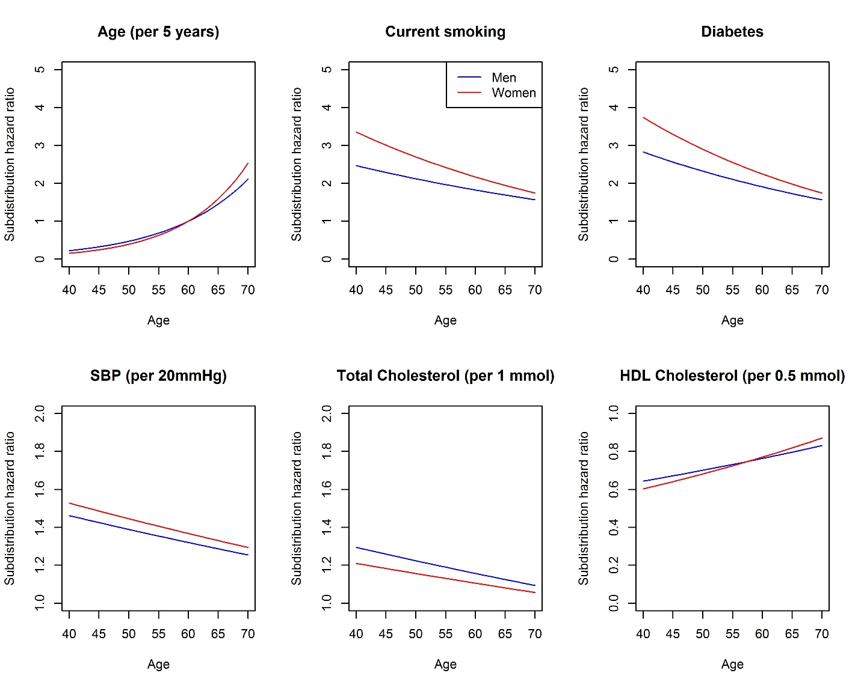

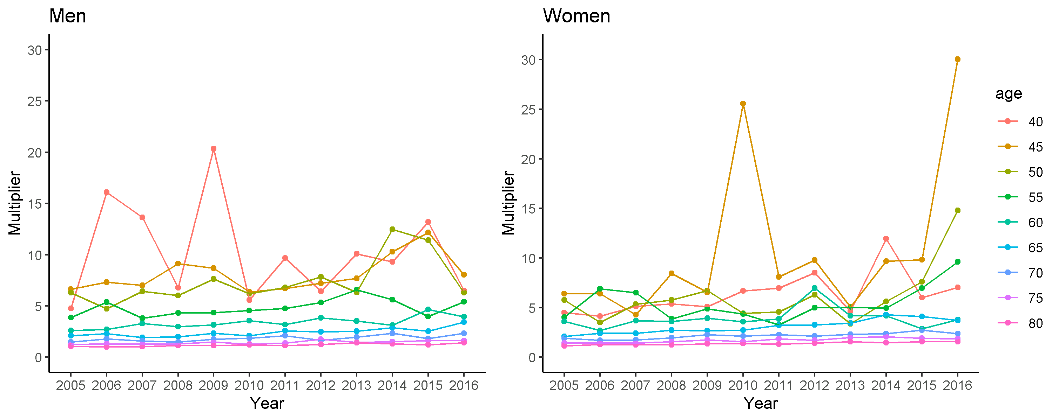
Supplementary Figure 3: Temporal differences in multiplication factors from CPRD

Multiplication factors in the low risk region, as calculated over single year intervals in CPRD, UK. Multiplication factors were defined as the ratio between the cumulative incidence of fatal CVD in the complete population and the cumulative incidence of CVD events in the population without prior CVD events.

Supplementary Figure 4: Aggregated and cohort-specific multiplication factors
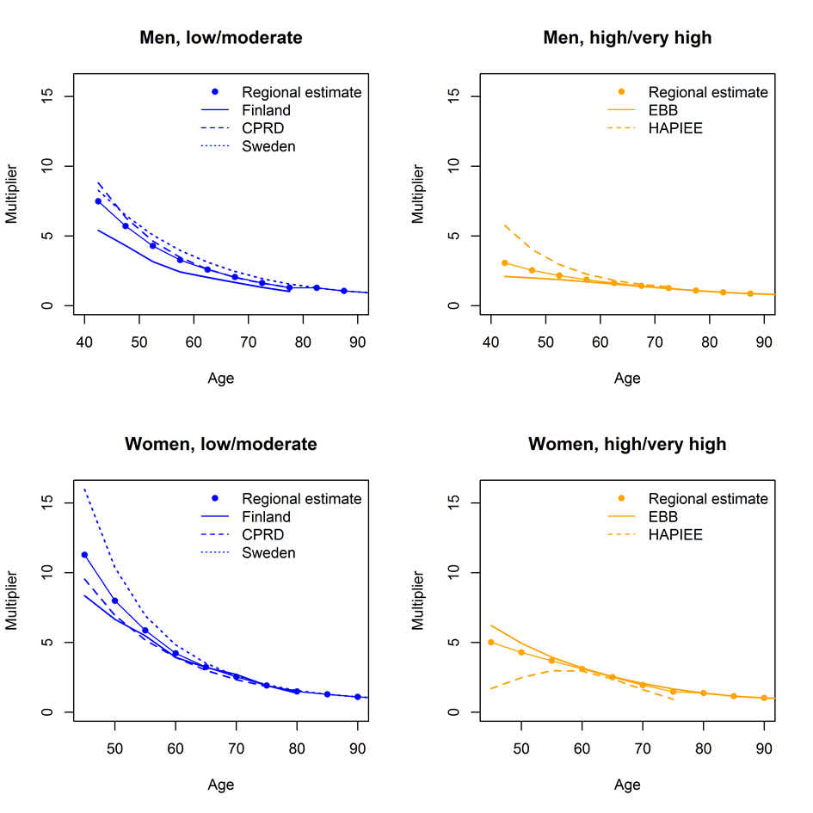
Multiplication factors as derived in all relevant cohorts. The regional estimate lines shows the final multiplication factors as used for the recalibration, a weighted mean of the regional cohort-specific estimates.

Supplementary Figure 5: Comparison of SCORE2 age and sex specific-multipliers with those estimated in several validation cohorts
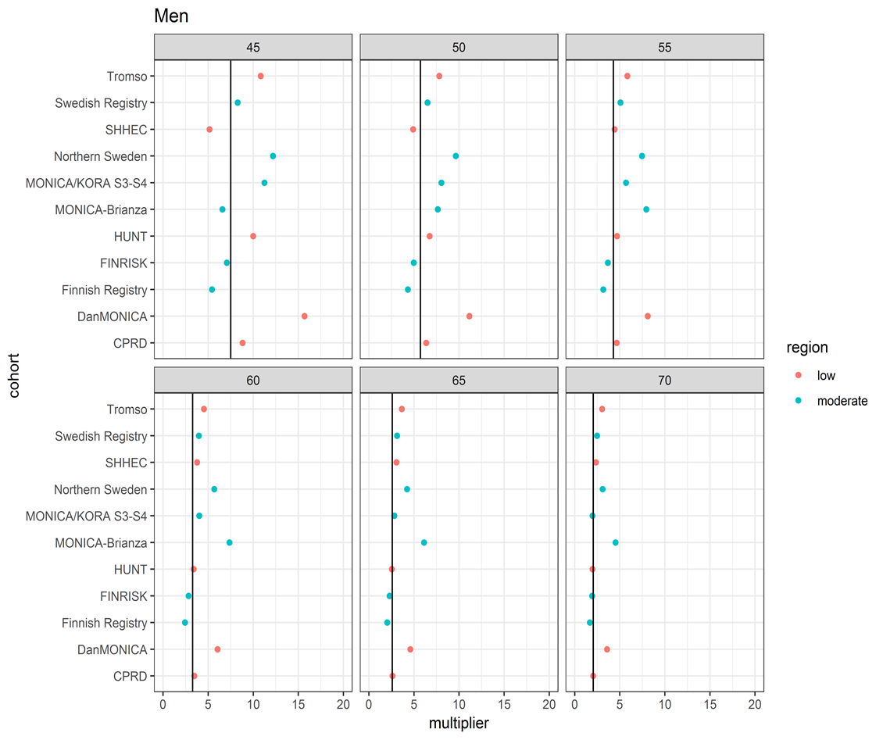
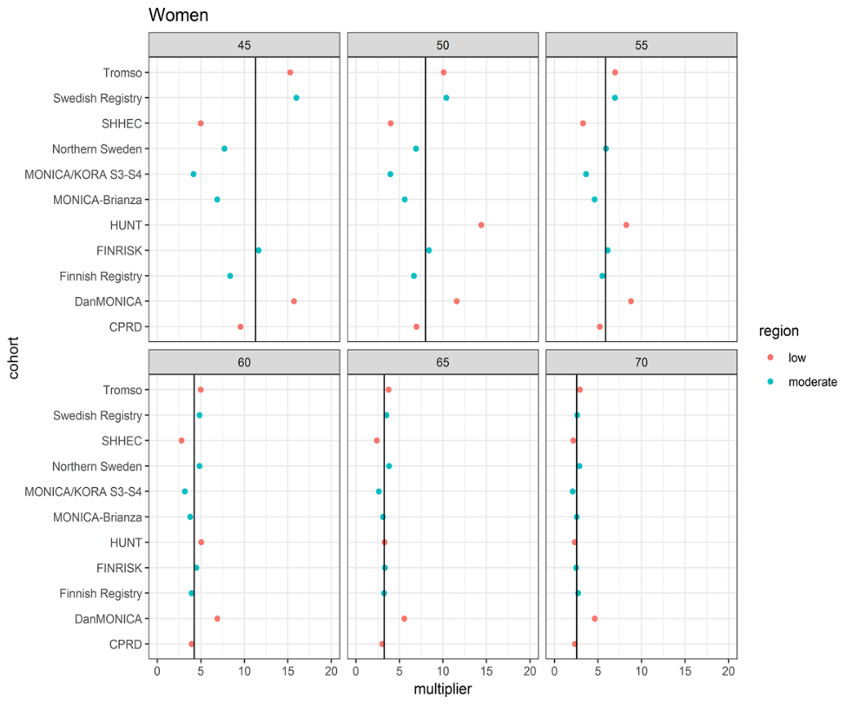
Verticle line indicates the pooled SCORE2 multiplier, as shown in Supplementary Figure 4 and Supplementary Table 9

Supplementary Figure 6: Regional risk factor levels used for recalibration
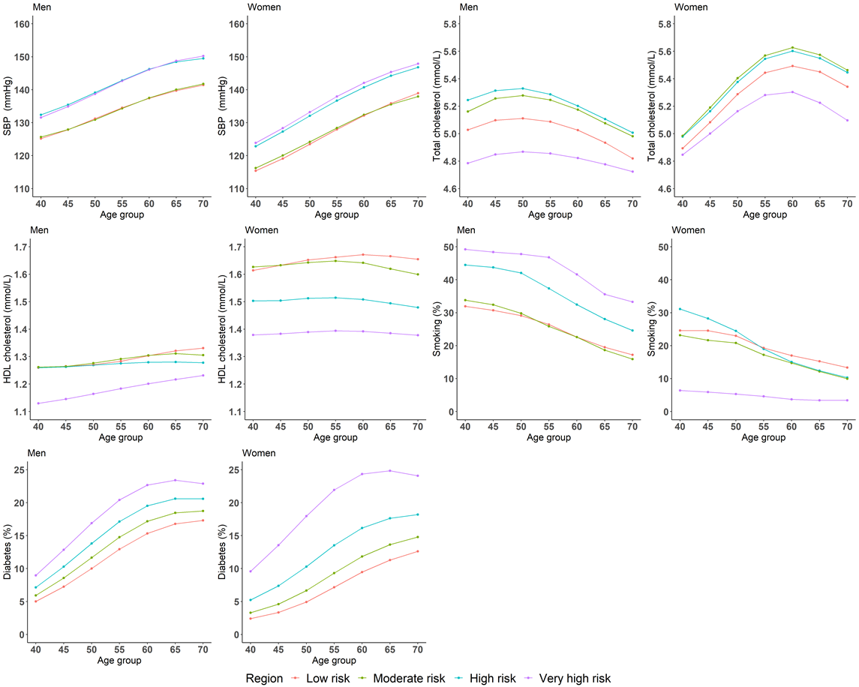

Supplementary Figure 7: Cardiovascular mortality, derived incidence, and multipliers by risk region
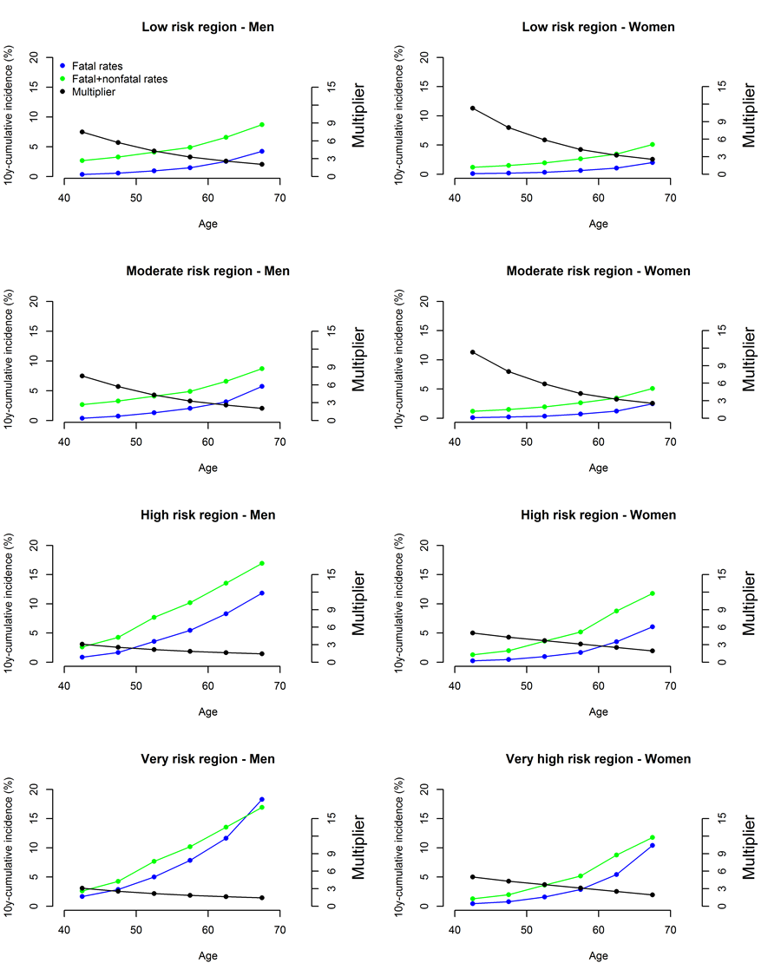

Supplementary Figure 8: Cardiovascular mortality and derived incidence in all risk regions
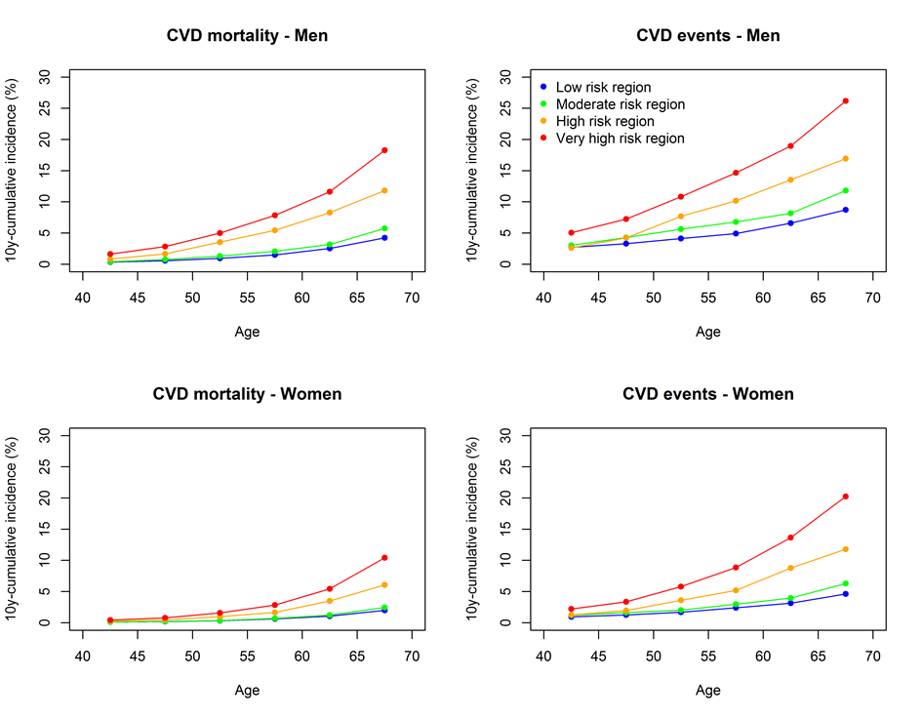
10-year cumulative incidences of cardiovascular mortality (left) and fatal or non-fatal cardiovascular events (right) in every region for every age-group.

Supplementary Figure 9: Estimated CVD incidence rates and predicted risks
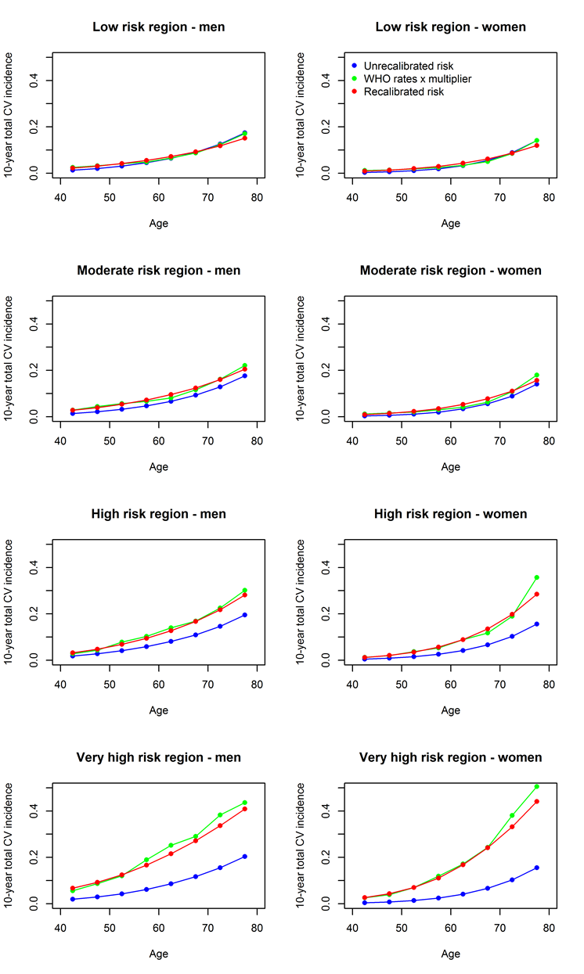
Supplementary Figure 10: Validation of estimated CVD incidence against independent registry data

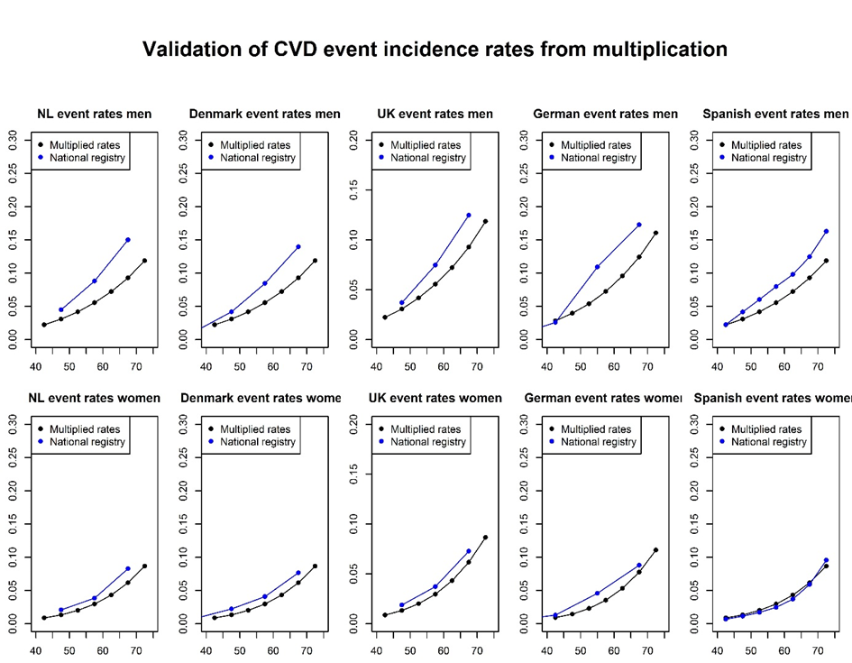

Comparison of registry-based incidence rates of total and fatal cardiovascular disease, with those used in the recalibrated SCORE2. The SCORE2 predicted risks were obtained by combining regional NCD risk factor levels to the risk algorithms. Registry incidences were extrapolated to a 10-year cumulative incidence. Note that Netherlands, German and Spanish registry-based incidences include also CVD events in patients with prior vascular disease. Only the Spanish registry rates have been corrected for competing risks.

Supplementary Figure 11: Predicted 10-year cardiovascular disease risks for an individual with total cholesterol concentration of 5.5 mmol/L, HDL cholesterol of 1.3 mmol/L, and systolic blood pressure of 140 mm Hg, for each region

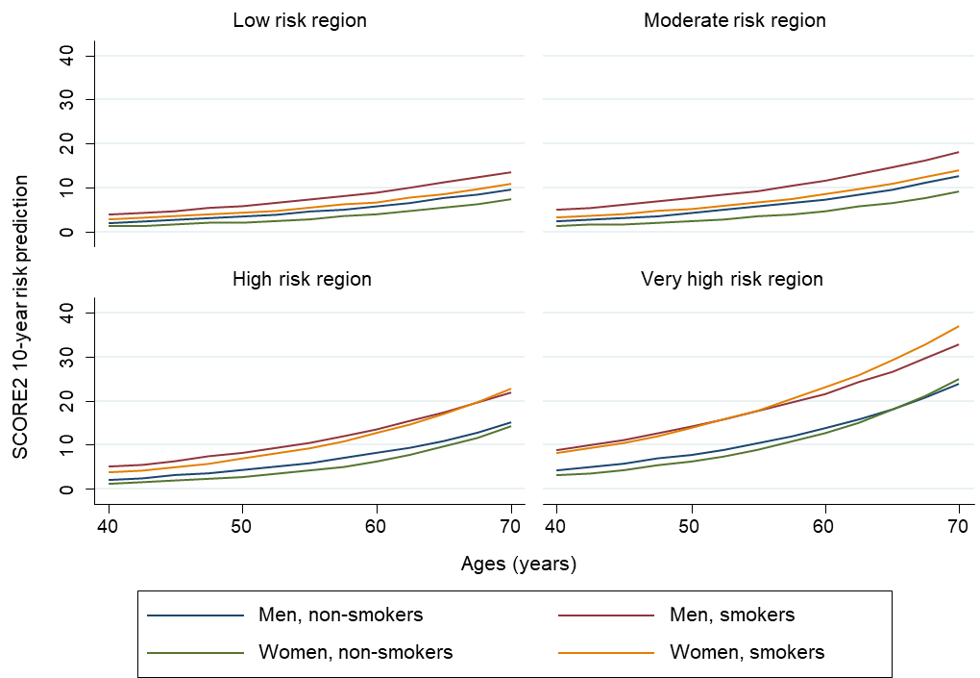
Supplementary Figure 12: Distributions of predicted risks for cases and non-cases
Supplementary Figure 13: Calibration of SCORE and SCORE2 in CPRD data
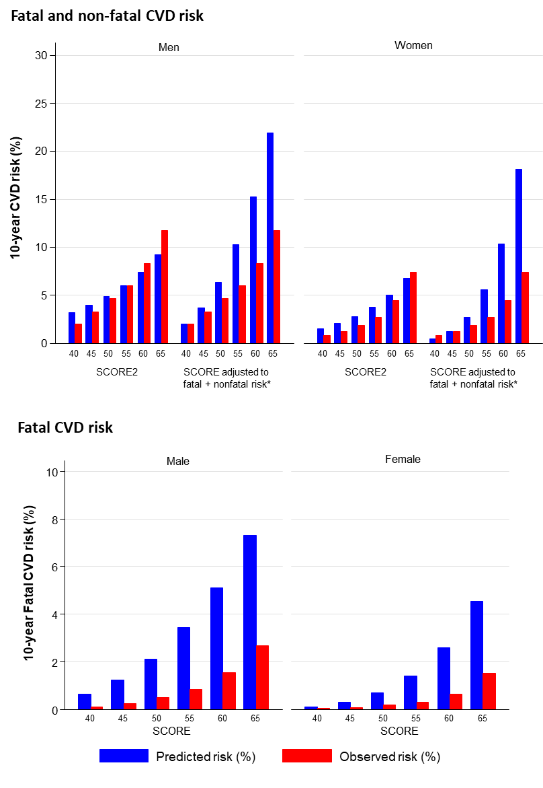
Conversion of fatal CVD risk estimated using SCORE to fatal and non-fatal CVD risk, was completed using the approach recommended by the 2019 ESC/EAS Guidelines for the Management of Dyslipidaemias (i.e., to multiply estimates by 3 in men and by 4 in women).

Supplementary Figure 14: Risk stratification using SCORE2 and SCORE and observed lifetime risk of CVD

Comparison of appropriateness of risk stratification using SCORE2 and SCORE in CPRD assuming that both were used to independently select 20% of the population at "high-risk". Observed CVD risk over the lifetime were devided into four groups according to "high-risk" status using SCORE and SCORE2.

Supplementary Figure 15: SCORE2 and SCORE risk distributions by age and risk region
SCORE2
SCORE

The proportion of individuals expected in each risk category was estimated to reflect the age-group and sex- specific risk factor values and specific population structure of each country (Supplementary Methods 1.3)
List of investigators
Augsburg (KORA): Annette Peters, Barbara Thorand; ATENA: Salvatore Panico, Paolo Chiodini; ARIC: Kuni Matsushita, Anna Kucharska-Newton; ATTICA: Ekavi Georgousopoulou; BRIANZA: Marco Ferrario, Giancarlo Cesana; BRUN: Gregorio Rungger, Georg Egger, Karin Willeit; BWHHS: Julie Taylor, Caroline Dale, David Prieto-Merino; CHS1: Bruce M Psaty, Richard A Kronmal; CHS2: Bruce M Psaty, Richard A Kronmal; COPEN: Gorm B Jensen, Marianne Benn, Ruth Frikke-Schmidt; DANMONICA: Torben Jørgensen, Allan Linneberg; DESIR: Beverley Balkau, Michel Marre, Frederic Fumeron; DETECT: David Leistner, Jens Klotsche; DRECE: Carmen Romero, Cristina Martín-Arriscado, Pilar Cancelas Navia; EMOFRI: Diego Vanuzzo, Giovanni Veronesi, Chiara Donfrancesco; EPICNOR1: Nicholas J Wareham; ESTHER: Xin Gao, Bernd Holleczek, Hannah Stocker; FINNMARK: Inger Ariansen, Lise Lund Håheim; FINRISK: Pekka Jousilahti, Veikko Salomaa; Finnish CVD register: Arto Pietilä, Veikko Salomaa; GHS: Philipp Wild, Thomas Münzel; GOTO43: George Lappas; HCS: Karen Jameson; HONOL: Beatriz Rodriguez; HOORN: Petra Elders, Femke Rutters; HUBRO: Inger Ariansen, Lise Lund Håheim; HUNT: Torbjørn Omland, Kristian Hveem, Magnus Lyngbakken; KAUNAS: Abdonas Tamosiunas, Dalia Luksiene; LEADER: Jackie A Cooper; MATISS93-95: Simona Giampaoli, Luigi Palmieri, Chiara Donfrancesco; MESA: Aaron Folsom, Ian de Boer; MIDFAM: Naveed Sattar; MOLI-SANI: Licia Iacoviello, Augusto Di Castelnuovo; MONICA Catalonia: Susana Sans; MONFRI94: Diego Vanuzzo, Giovanni Veronesi; MORGAM: Kari Kuulasmaa, Veikko Salomaa, Giovanni Veronesi, Frank Kee, Wolfgang König, Hugh Tunstall-Pedoe, Ellisiv Mathiesen, Barbara Thorand, Stefan Blankenberg, Francisco Ojeda, Tanja Zeller, Christina Magnussen, Christoph Waldeyer, Fabian Brunner, Thiess Lorenz, Bijoy Joseph; MORGEN: Anneke Blokstra; MOSWEGOT: George Lappas; Northern Sweden: Stefan Söderberg, Mats Eliasson; NHANESIII: Richard F Gillum; NSHS: Susan Kirkland, Daichi Shimbo, Jonathan Shaffer; OPPHED: Inger Ariansen, Lise Lund Håheim; OSLO2: Inger Ariansen, Lise Lund Håheim; PAMELA: Guido Grassi, Fosca Quarti-Trevano; PREVEND: Rudolf A de Boer, Lyanne M Kieneker; PRIME: Philippe Amouyel; ProspectEPIC: Karel G M Moons; PROSPER: Stella Trompet, Ian Ford; RS_I: M Arfan Ikram, Banafsheh Arshi, Elif Aribas; RS_II: M Arfan Ikram, Banafsheh Arshi, Elif Aribas; SHHS: Hugh Tunstall-Pedoe, Mark Woodward SHIP: Marcello P Markus, Carsten O Schmidt, Stephan B Felix; TROMS: Inger Ariansen, Lise Lund Håheim; TROMSØ: Tom Wilsgaard, Ellisiv B Mathiesen; USPHS2: Paul M Ridker, Nancy R Cook, Julie Buring; WHITEII: Eric J Brunner, Mika Kivimaki; WHITEI: Eric J Brunner, Mika Kivimaki; WHS: Paul M Ridker, Nancy R Cook, Julie Buring; WOSCOPS: Michele Robertson, Robin Young, Peter Macfarlane; ZARAGOZA: Alejandro Marín Ibañez. Heinz-Nixdorf Recall: Karl-HeinzJöckel, Raimund Erbel, Sara Schramm; Estonian Biobank: Reedik Mägi, Krista Fischer, Andres Metspalu, Tõnu Esko, Lili Milani; NCD Risk Factor Collaboration: Bin Zhou.

